< Tian Xie >

< 3/13/2020 >

< IT FDN 100 >

< Assignment 08 >

Document my knowledge

# Introduction

For the 8th assignment, the task is to modify a starter script to use classes, objects, constructors, etc.

This week we learned the components that make up a class. Here are some definitions in my own words.

Attributes: are assignment statements that assigns a value to a variable outside of a method.

Static method: is a decorator, it does not need “self” or other arguments (parameter).

Private attributes: these are used to limit direct access to object from the user. It has double underscores. You can also create private methods.

# Steps to Complete the Assignment

To complete the assignment, I watched the recommended YouTube videos and read chapter 8 of the book. Then I followed all the steps in the assignment document.

The first thing I did was to figure it out what needs to be done by looking at the pseudocode.

By looking at the pseudocode, I started to fill out the blanks using codes from the previous week. I moved the main body and class IO. I then updated all the docstring. I noticed that the list of objects is defined as lstofCDObjects in the beginning so I updated all of my varibles to be consistent. I also modified the read_file and write_file functions to save_inventory and load inventory methods. Last week, I didn’t add error handling to the del_inventory method but now I added it.

I added class CD next. First, I added the constructor: the dunder init method, this is implicitly called by python when creating an object and passes arguments provided. Then I added property and setters to define the characteristics of the CD class. One thing I forgot to add was when using pickle I need to assign the returned data structure back to the global variable which I did in the default load but not the manual load call in line 240.

I updated the add_inventory method to use the CD class to instantiate added_cdobj.

def add_inventory(cd_id, cd_title, cd_artist, lst_cdObj):  
 added_cdObj = CD(cd_id, cd_title, cd_artist)  
 lst_cdObj.append(added_cdObj)  
 return lst_cdObj

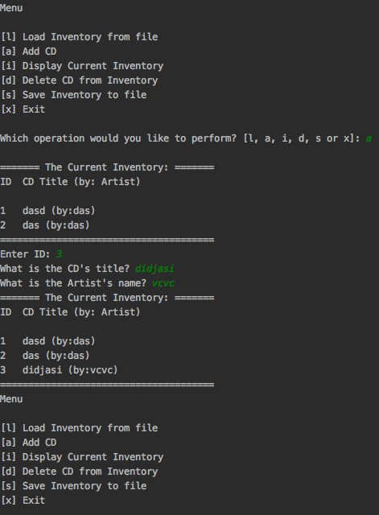

Figure 1Pycharm Screenshot showing adding works

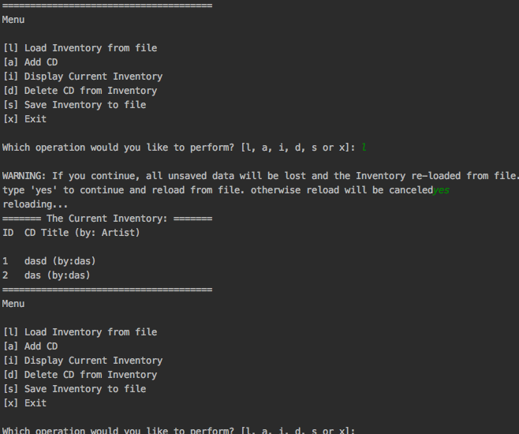

Figure Pycharm screenshot showing loading function works

# 

Figure Pycharm screenshot showing deletion function works

# Summary

Module 08 was definitely more challenging. A lot of the concepts take time to grasp. It took me a long time after reviewing multiple sources to understand OOP. After this week, I now know how to create a proper class and add its attribute, set them private (restrict access). I know how to write methods within a class and how to instantiate objects from a class. I can’t wait to re-write some of my previous projects to include class and see how I can make my code more elegant.

# References

<https://docs.python.org/3/tutorial/errors.html>

<https://youtu.be/lkXfgP-fAkY>

<https://youtu.be/KZdFvyCOLUQ>

<https://youtu.be/qvRyls8NX-E>

https://realpython.com/python3-object-oriented-programming/

# Appendix

Github link: https://github.com/tianxie812/Assignment_08